AFFG — Veeam Backup for Microsoft 365
Monthly Backup Report — 2026-02
M365 tenant: NETORGFT9014011.onmicrosoft.com
Report generated: 2026-05-02 18:21
Executive Summary
34 M365 users in this tenant are protected by Veeam Backup for Microsoft 365. Total backup storage in use is 921.26 GB across 1 repository, with 1 active backup job. This report breaks down storage by Microsoft 365 service, lists per-user backup coverage, and projects how storage will grow over the next 12 months.
34  M365 Users | 20  Users w/ OneDrive backed up | 921.26 GB  Backup Storage Used | 1  Backup Jobs (Running)
Backup Posture
Job | Backup Type | Last Run | Status | Enabled | Next Run
AFFG-O365 | EntireOrganization | 2026-05-01T10:12:43.4918789Z | Running | Yes | 2026-05-02T20:05:00Z
Backup repositories:
Repository | Used | Capacity | Free | Path
AFFG-O365 | 921.26 GB | 1023.98 GB | 84.79 GB | C:\O365 Backups\bkp_AFFG-365

Storage by M365 Module
Per-module bytes are estimated by attributing the tenant's total used backup storage in proportion to how often each service appeared in restore points over the last 90 days, weighted by industry-default ratios. For exact per-mailbox / per-site sizes, run the VB365 PowerShell module (Get-VBOEntityData).
Module | Estimated Storage | Share of Total | RP coverage (last 90d)
Exchange | 434.31 GB | 47.1% | 3 / 5
OneDrive | 329.02 GB | 35.7% | 5 / 5
SharePoint | 118.45 GB | 12.9% | 3 / 5
Teams | 39.48 GB | 4.3% | 3 / 5
Per-User Backup Coverage
34 users in the M365 directory. Mailbox coverage is set Yes for every user when the job is EntireOrganization (current setting). OneDrive coverage is determined by probing /users/{id}/onedrives.
Display Name | Email | Mailbox | OneDrive
Hao Liu | hao.liu@americanfundstars.com | Yes | Yes
Daniel Feng | daniel.feng@americanfundstars.com | Yes | Yes
Ted Zhou | ted.zhou@americanfundstars.com | Yes | No
Xinda Yang | frank.yang@americanfundstars.com | Yes | Yes
fengfan.daniel@gmail.com | fengfan.daniel__gmail.com@NETORGFT9014011.onmicrosoft.com | Yes | No
American Fundstars Financial Group | AmericanFundstarsFinancialGroup@NETORGFT9014011.onmicrosoft.com | Yes | No
Jason Zhou FS | JasonZhouFS@NETORGFT9014011.onmicrosoft.com | Yes | No
Marco Fu | marco.fu@americanfundstars.com | Yes | Yes
Qingqing Cao | qingqing.cao@americanfundstars.com | Yes | No
Andrew Yuan | andrew.yuan@americanfundstars.com | Yes | No
Yu Maggie | maggie.yu@americanfundstars.com | Yes | Yes
June Feng | june.feng@americanfundstars.com | Yes | Yes
Technijian Helpdesk | Technijian@americanfundstars.com | Yes | No
Xiaohui Xia | frank.xia@americanfundstars.com | Yes | Yes
American Fundstars | info@americanfundstars.com | Yes | Yes
Human Resource | hr@americanfundstars.com | Yes | Yes
Jason Zhou | jason.zhou@americanfundstars.com | Yes | Yes
Selene Pan | selene.pan@americanfundstars.com | Yes | Yes
Kiki Wang | kiki.wang@americanfundstars.com | Yes | Yes
Leo Zhou | leo.zhou@americanfundstars.com | Yes | Yes
americanfundstars.com | admin@NETORGFT9014011.onmicrosoft.com | Yes | No
Dan Wang | dan.wang@americanfundstars.com | Yes | Yes
Toby Zhu | toby.zhu@americanfundstars.com | Yes | Yes
Daniel Feng Appointment | DanielFengAppointment@NETORGFT9014011.onmicrosoft.com | Yes | No
Iris Liu | iris.liu@americanfundstars.com | Yes | Yes
Mailbox to receive journal reports when journaling mailbox is unavailable | JournalingNDR@NETORGFT9014011.onmicrosoft.com | Yes | No
Leon Liang | leon.liang@americanfundstars.com | Yes | Yes
Alyssa Mu | alyssa.mu@americanfundstars.com | Yes | Yes
Discovery Search Mailbox | DiscoverySearchMailbox{D919BA05-46A6-415f-80AD-7E09334BB852}@NETORGFT9014011.onmicrosoft.com | Yes | No
AFS Billing | billing@americanfundstars.com | Yes | No
Yuxin Tian | tim.tian@americanfundstars.com | Yes | Yes
Jason Zhou FS | JasonZhouFS1@NETORGFT9014011.onmicrosoft.com | Yes | No
RD Meeting | RDMeeting@NETORGFT9014011.onmicrosoft.com | Yes | No
Steve He | steve.he@americanfundstars.com | Yes | Yes

Storage Trend & Projection
Projection method: industry default 4% MoM (will refine after 2+ monthly snapshots). Compound monthly growth rate used: 4.00%.
Horizon | Projected Storage | Δ vs today
Today (snapshot) | 921.26 GB | —
+3 months | 1.01 TB | +115.03 GB
+6 months | 1.14 TB | +244.43 GB
+9 months | 1.28 TB | +389.98 GB
+12 months | 1.44 TB | +553.71 GB
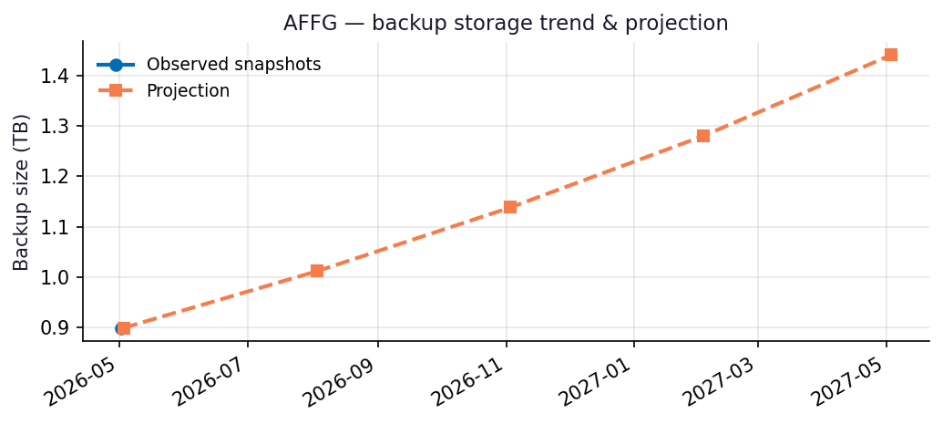
Recommendations
- Repository AFFG-O365 is 92% full (84.79 GB free of 1023.98 GB capacity).
- Capacity flag: Repository will hit ~90% utilization within 3 months at the current trend — begin capacity planning now.
- Run this report monthly. The projection accuracy improves with each snapshot — after 3 snapshots the linear-regression fit replaces the industry-default growth assumption.

Appendix: Methodology & Data Sources
Data sources
- Veeam Backup for Microsoft 365 REST API at https://10.7.9.227:4443/v8 (OAuth2 password grant; self-signed TLS).
- Endpoints used: /Organizations, /Organizations/{id}/usedRepositories, /Organizations/{id}/users, /Organizations/{id}/users/{uid}/onedrives, /BackupRepositories, /Jobs, /RestorePoints?backupTimeFrom=...
Per-module attribution caveat
REST does not expose per-mailbox or per-OneDrive backup byte counts on this build. Per-module estimates reweight the total used storage by the share of restore points (over the trailing 90 days) that included each service. Treat the numbers as informed estimates, not invoiced figures. For ground-truth per-user/per-team sizes use the VB365 PowerShell module Get-VBOEntityData.
Trend projection
- With <2 monthly snapshots: project at 4%/month compound.
- With ≥2 snapshots: linear regression on log(bytes) over time.

